|  |  |
| --- | --- |
|  |  |

|  |  |
| --- | --- |
| **院別：** | **機電學院** |
| **系別：** | **機械與自動化工程系** |
| **學制：** | **日間部 四技** |

**110 學年度 專題研究報告**

**題目：以○○○○控制○○○○○○**

**Controlling ○○○○○○○○ from your ○○○○○○**

**研究組員**

|  |  |  |  |
| --- | --- | --- | --- |
| **學號** | **姓名** | **學號** | **姓名** |
| **40081M3○○○** | **○○○** | **40081M3○○○** | **○○○** |
| **40081M3○○○** | **○○○** | **40081M3○○○** | **○○○** |

**指導老師： ○ ○ ○**

**中華民國111年06月**

|  |  |
| --- | --- |
|  |  |

|  |  |
| --- | --- |
| **院別：** | **機電學院** |
| **系別：** | **機械與自動化工程系** |
| **學制：** | **日間部 四技** |

**110 學年度 專題研究報告**

|  |  |
| --- | --- |
| **題目：** | **以○○○○控制○○○○○○**  **Controlling ○○○○○○○○ from your ○○○○○○** |
| **研究組員：** | **○○○、○○○、○○○、○○○** |
| **指導老師：** | (簽名) |

**經審查合格特此證明**

**專題審查委員**

|  |  |
| --- | --- |
| **召集人：** | (簽名) |
| **委員：** | (簽名) |
| **委員：** | (簽名) |
| **委員：** | (簽名) |

**中華民國111年06月**

**Abstract**

This paper provides an overview of the design features of Jiggy and a synthesis of the research that has been done throughout its development. All of us know how artificial intelligence is rising in the marketplace and the market is receiving totally reliant on artificial intelligence for responsibility the multifaceted tasks that includes dancing. …………

Keywords: Synthesis, Pandemic, …….

**Table of Contents**

Abstract I

List of Figures IV

Table of Contents V

Chapter 1: Introduction 1

1.1 Preface 1

1.2 Research Motivation 2

1.3 Future Development Direction 2

Chapter 2: Basic Theory 4

Chapter 3: Expiremental Architecture and Introduction of Parts Used 18

Chapter 4: Results and Discussion 9

Chapter 5: Conclusion 9

References 10

**List of Figures**

Figure 1-1 3

**Table of Contents**

Table 1-1 專題報告基本架構 2

Chapter 1 Introduction

Taiwan is now one of the countries that is actively engaged in robotics research and development. Because robots have actual bodies, communication between them and humans is more extensive than communication between computer characters and humans. However, because robots' current capabilities are insufficient to assist us in different aspects of our life, one of their most important applications is entertainment.

The importance of entertainment in our daily lives cannot be overstated. Entertainment calms us down, makes us happy, and consequently benefits our mental health. Despite the fact that there are many different sorts of entertainment, dance is unique in that it activates both our body and our brain.

………….

1.1 Preface

We all know that these robots' skills are currently restricted, they are projected to assist us in different parts of our daily lives in the future. Installing such a task in robots is, however, quite challenging at the moment. Entertainment may be an excellent application area for robots to break through in such a setting. In our daily lives, entertainment plays a critical part. It promotes mental well-being by promoting relaxation. Dance occupies a unique position among many forms of entertainment in that it engages both the body and the mind. Dance is also one of the most advanced forms of nonverbal communication. From a variety of perspectives, creating a dancing robot would be incredible.

Chapter 2 Basic theory

2.1 Entertainment and Robot

2.1.1. Introduction to Entertainment

There are so many aspects to consider and discuss concerning entertainment. Entertainment is something that holds the attention and interest of an audience,………

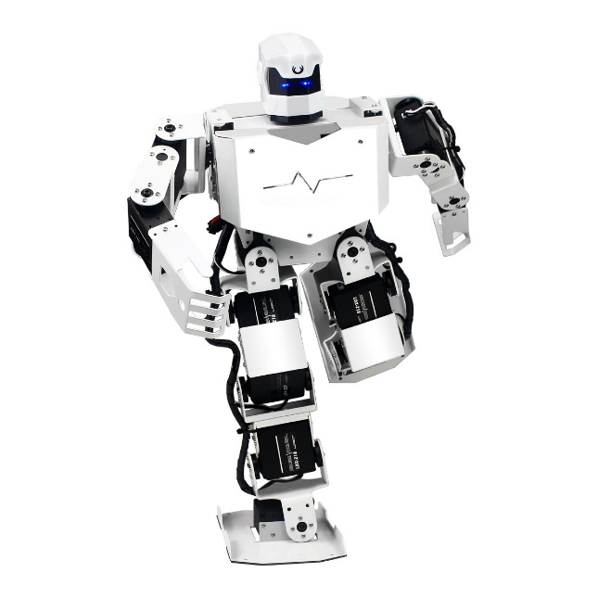

**Figure 2-1 An example of a humanoid robot [5]**

**Table 2-1 The moving range of the robot [6]**

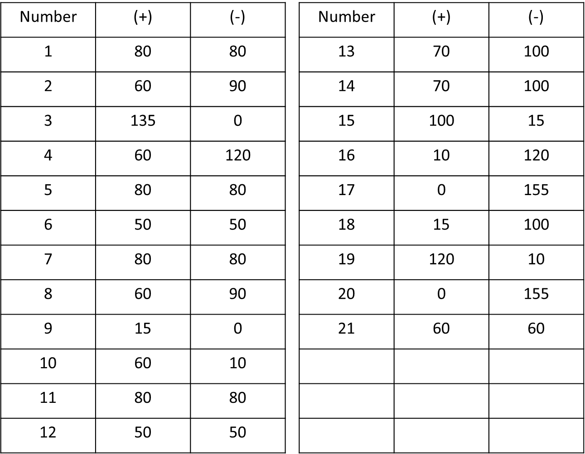

References

[1]<https://www.definitions.net/definition/Entertainment#:~:text=Entertainment%20is%20something%20that%20holds%20the%20attention%20and,for%20the%20purpose%20of%20keeping%20an%20audience%27s%20attention>.

[2] <https://en.wikipedia.org/wiki/AIBO>

[3] https://en.wikipedia.org/wiki/ASIMO